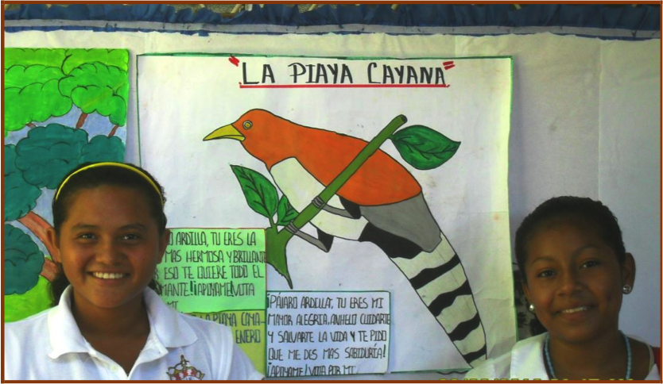
Education is a crucial part of every child’s development. In some countries, education is considered a lesser priority while simply trying to survive is the highest. There are several websites pertaining to education, such as The United Nations Development Programme and the Global Education First Initiative, which can help these children get an education and have a set of goals on how to accomplish this. “The Initiative’s main priorities are to expand access to education, improve the quality of learning, and foster global citizenship (G.E.F.I)”. In Greenland, “The first political action after the establishment of Home Rule in 1979 was the enactment of a new school statute, in which it was stipulated that the language of instruction should be Greenlandic. There was also the stipulation that the contents of the school subjects should to a greater extent be adjusted to the needs of Greenlandic society (HolaKo)”.
Picture 1: Public school children showing their project on an endangered bird
In Greenland, the education is free for all “Greenlandic children between the ages of 6 and 15 and the standards are identical to those in place in Denmak(Illstorm)”. “An obligatory nine year elementary and middle school were established, upon completion of which students could choose to attend a two year ‘Continuation School’, completion of which would confer a public school diploma. If students had the need for further qualifications, they could choose to continue in a ‘Course School’ and receive instruction that met their needs (HolaKo)”. ” Once children complete their primary school education, secondary education is available at boarding schools while vocational school training is available (Illstorm)”. It is crucial to keep students continuing with their schooling after they finish primary school. They should always expand on their knowledge and that will help them live a more prosperous life. “The students were distributed among 24 town schools, 62 settlement schools and one school for the specially handicapped (HolaKo)”.
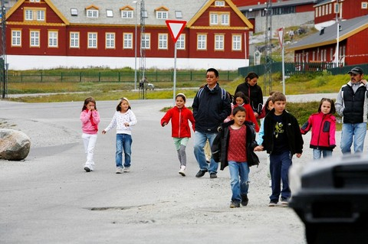
In Greenland, “ The local vocational schools have proven successful in many areas, giving young people basic technical knowledge, skills and positive attitudes within the area of training they have chosen. A two year educational residence at a local vocational school gives youths the qualifications to be ‘trainee’ workers in their field and also gives them the possibility of completing their education at a two year ‘trainee’ school with the writing of a journeyman's exam (HolaKo)”. In Greenland, educational buildings are located in Nuuk, the capital and main port of Greenland as well as Qaqortoaq, which is considered to be “education city with a high school, and is the center of commerce and trade in Southern Greenland (Milfeldt)”.
Picture 2: Schoolchildren in Nuuk, Greeland going to the play ground with the teacher during recess
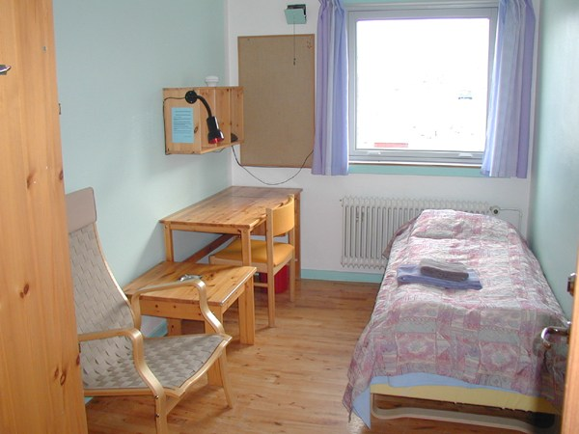
“The number of Greenlandic teachers will increase within the next few years and the number of hourly instructional assistants will decrease correspondingly. The steadily improving public school instruction ensures a growing number of students at the high school/college level, and this development has resulted in an increased number of recruitment possibilities for teacher education at Ilinniarfissuaq (HolaKo)”. To improve education in Greenland, “a new School Act was adopted in 1990. The intention behind the preparation of the School Act was that the quality of public school instruction and the benefit to the students should steadily develop. The Act also stipulates that Danish speaking students shall be integrated into Greenlandic speaking classes, beginning with Grade 1 in the school year 1994/95 (HolaKo)”. Some students may find it difficult to live at home while attending school. So, there are rooms and apartments available to the students to stay in while they are at school, similar to the dorms on college campuses. According to Knud Rasmussen Højskolia, the rooms you can rent have daily prices ranging from 450dkr to 1,000dkr; that is $65 to $145 USD. This improves the quality of learning by keeping the students close to or on campus where they can get help when needed and maintain a school-oriented mindset (HolaKo). In all, Greenland has taken great strides towards improving its educational program and continues to make changes to accommodate the demands of the population. This will not only improve the country as a whole, but also the standard of living for all Greenlanders.
Picture 3: A single bedroom without shower/toilet for students to live in on campus

Resources
- G.E.F.I.(2014). Priorities. Retrieved from http://www.globaleducationfirst.org/220.htm
- HolaKo.(2013).Education in Greenland. Retrieved from http://www.ankn.uaf.edu/IEW/EdGreen.html
- Milfeldt, M. (Ed.).(2014). Qaqortoq. Retrieved from http://www.greenland.com/en/destinations/south-greenland/qaqortoq/
- Kevin Illstorm.(2015). Countries and Their Cultures. Retrieved from http://www.everyculture.com/Ge-It/Greenland.html
Picture Resource
- Picture 1. Hotel Plaza Colon.(2013).Greenland is Melting…Is Nicaragua Flooding?. Retrieved from http://hotelplazacolon.com/greenland-is-melting-is-nicaragua-flooding/
- Picture 2.Yadid Levy.(2010).Nuuk,Greenland. Retrieved from http://www.robertharding.com/index.php?lang=en&page=preview&subpage=817-130564
- Picture 3. Knud Rasussen Højskolia.MLHTML. Retrieved from http://www.krh.gl/en-us/omkrh/rooms.aspx

